**PHASE 2 PROJECT**

**FLYAWAY.COM**

**Screenshots of all Scenarios in the Application:**

1. **Customer Related Scenarios:**
   1. **Home Page of FlyAway Website: Include options for Booking Flight, Admin Login, Customer Login.**

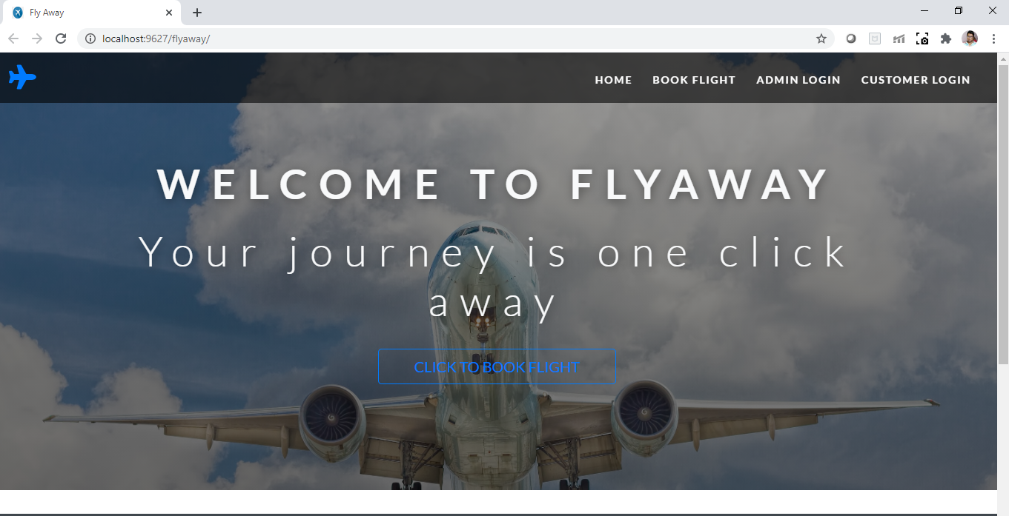



* 1. **When a new customer wants to Book a Flight (Navbar does not change). He is provided with a form to enter journey details.**

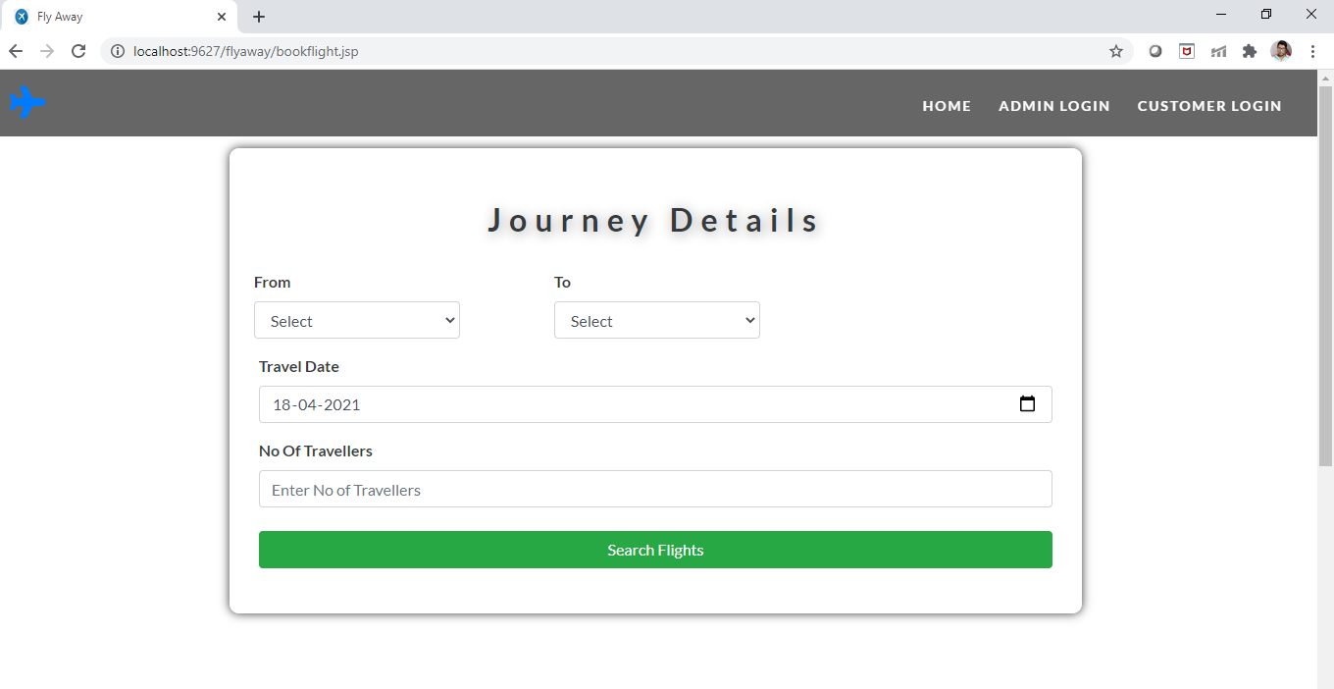

* 1. **Customer enter journey details here From: Mumbai, To: Delhi, Travel Date: 21-08-2022**

**No of passengers: 3.**

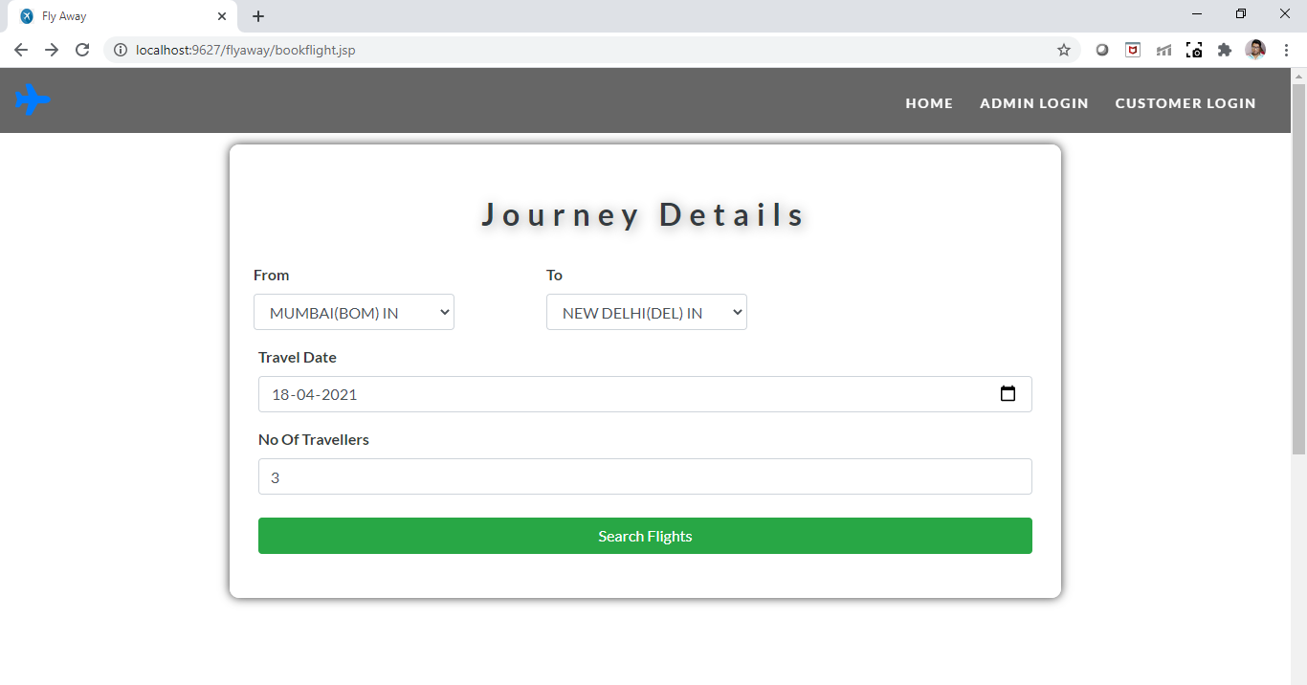

* 1. **If flights are available from the provided source to Destination, User will be directed to Flight details page where they will see all the flights available for the given date/day.**

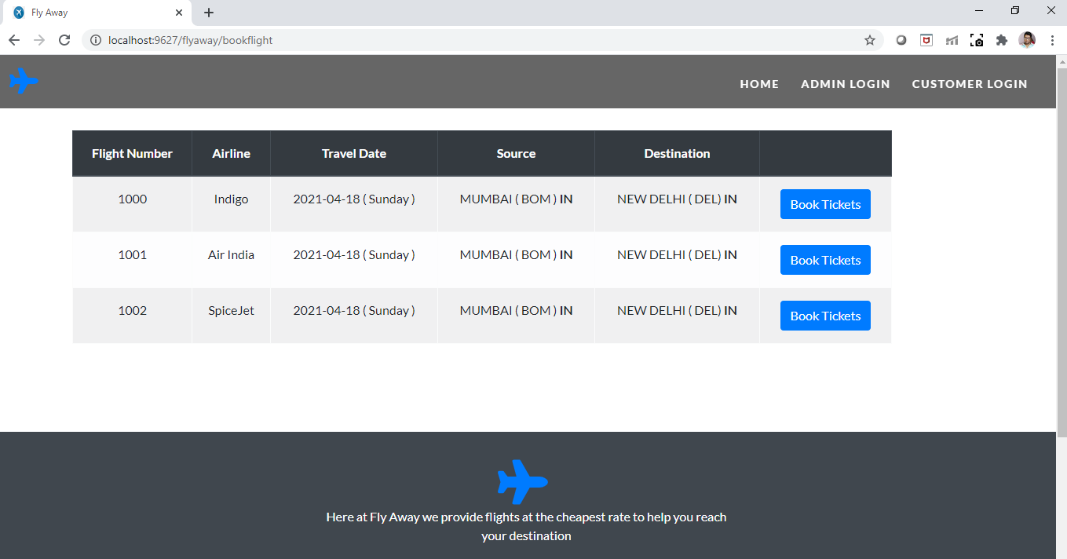

**We can see for Sunday 3 flights are present from Mumbai(BOM) to Delhi(DEL).**

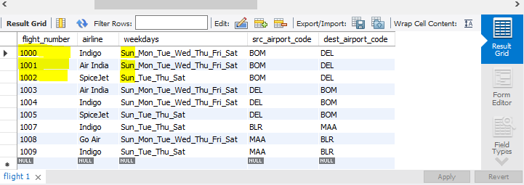

* 1. **Suppose User entered date as 21-08-2022which is Wednesday then he will be shown only flights which are available for Sunday.**

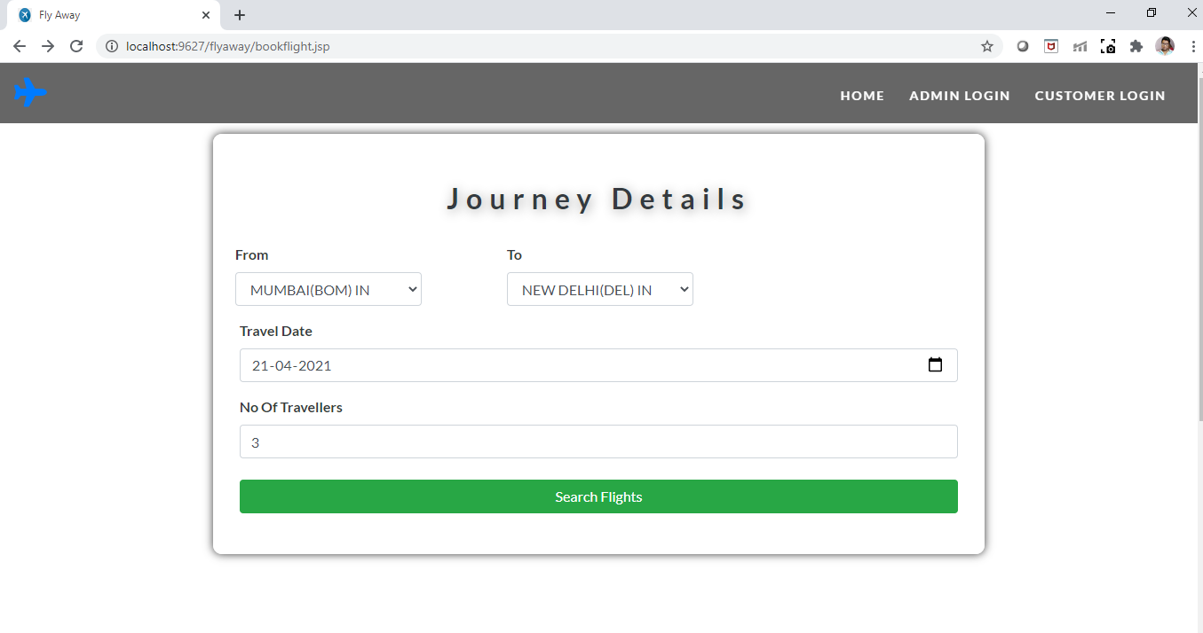

**We can see here only two flights are present for Sunday.**

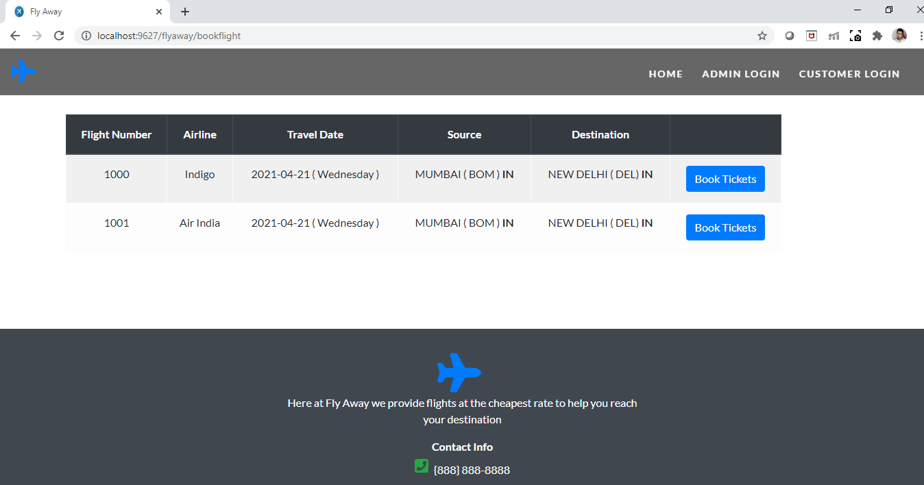

**We can also confirm the same in the database.**

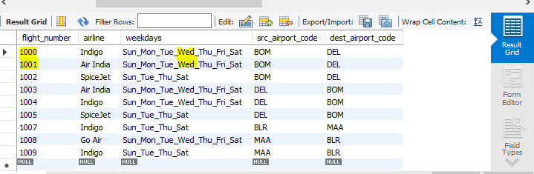

* 1. **If User enters details in the form for which flight is not available in the database**

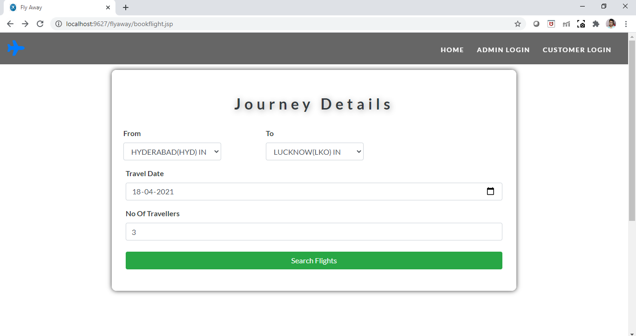

**User gets a message as There are no Flights for those details.**

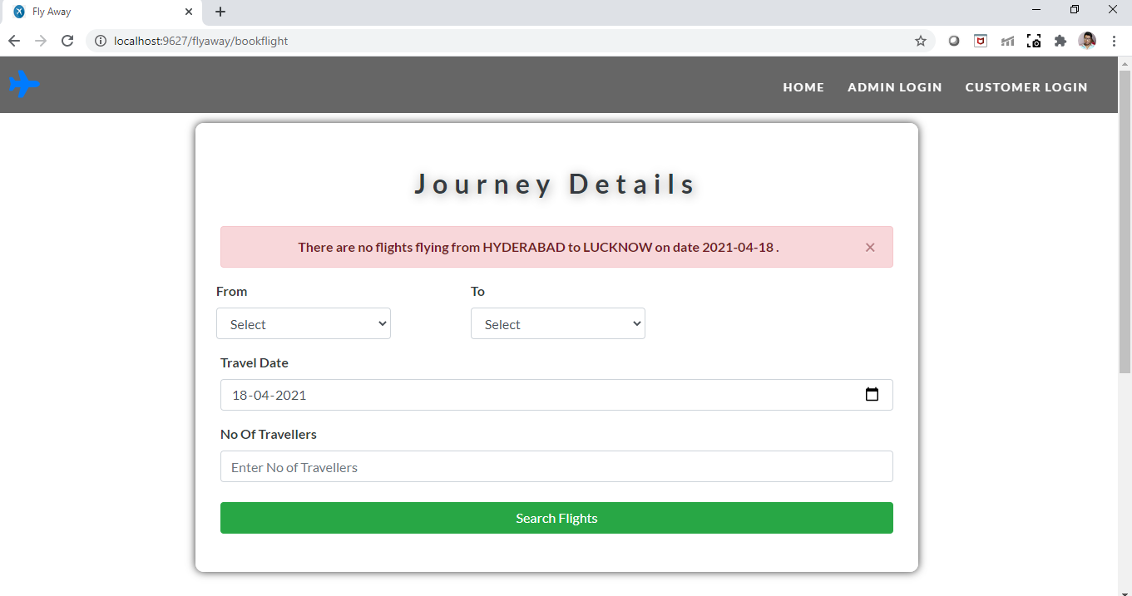

* 1. **If the user enters correct details in the Journey details form, All the flights available for that day is shown.**

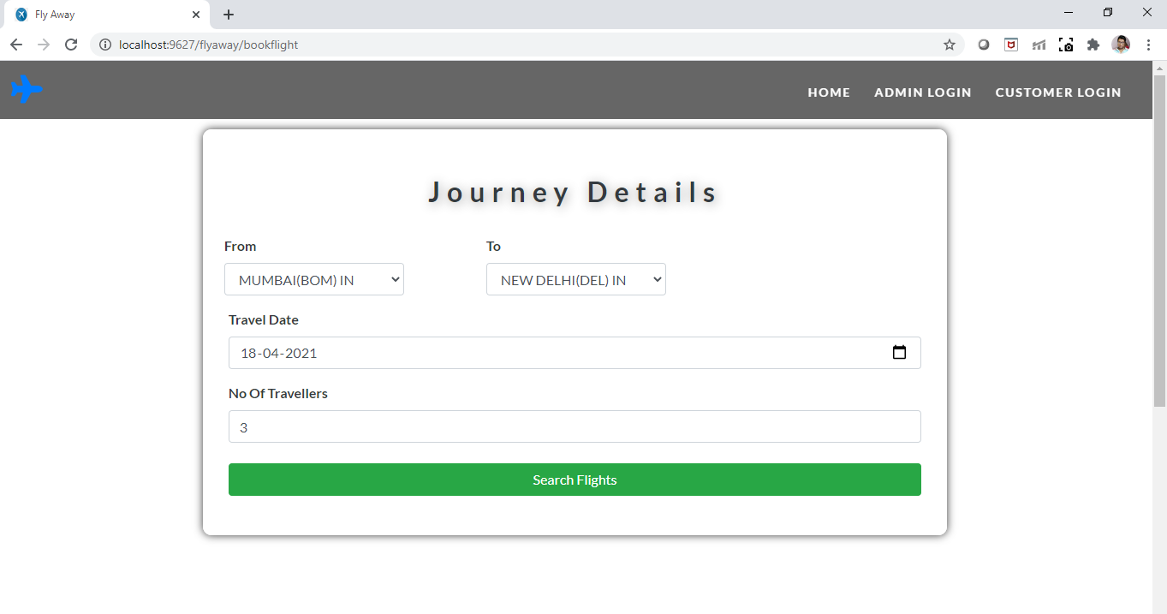

* 1. **User will be shown all the Flights available from Mumbai to Delhi on Sunday. User can select any airline from the list and compare their fares by clicking on (Book Tickets).**

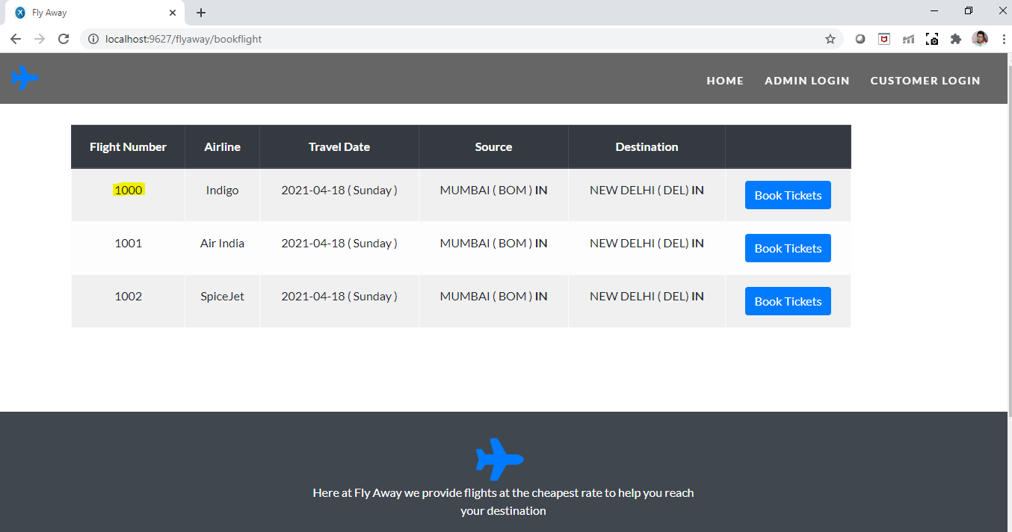

* 1. **If user selects an airline from the list (here 1000). User will be directed to fare details page where all the different classes are shown with fares. (User can book tickets on any class of their choice).**

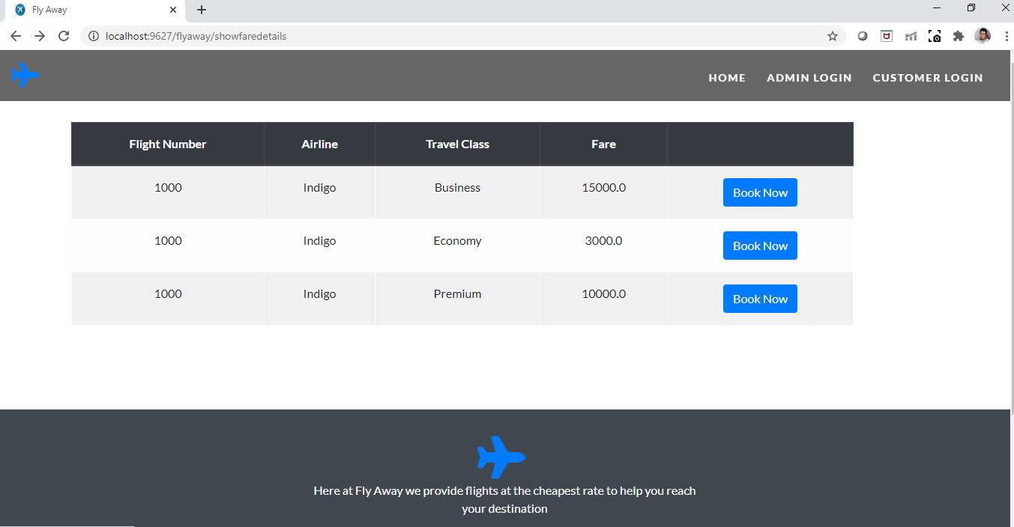

* 1. **If the user is a new customer, then after selecting a fare they will be redirected to Register page where they should enter their valid details, If the user is already existing customer then they can use Login in existing account option to directly login to their account.**

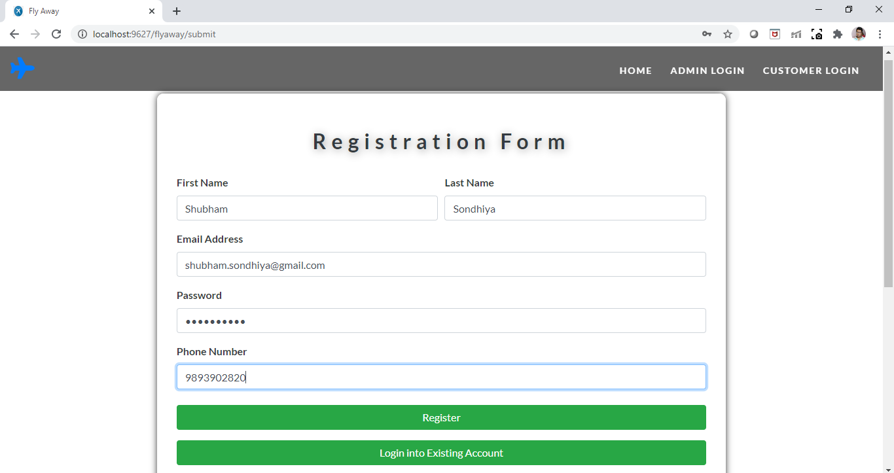

* 1. **After entering user details if the details are valid then they are redirected to Booking details page where they will see all their booking related details after confirming details, they can click on confirm Booking. (Notice navbar changed after login or register).**

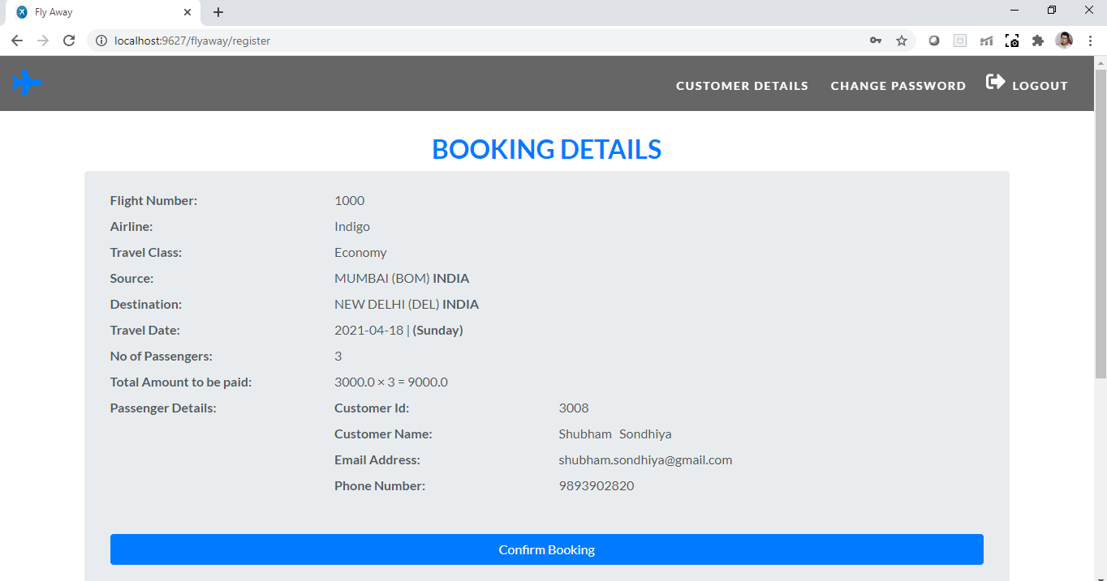

* 1. **After Confirming booking details, user will be forwarded to payment form where they need to enter payment details like Card Name and Card Number. They can also recheck the amount to be paid and confirm payment.**

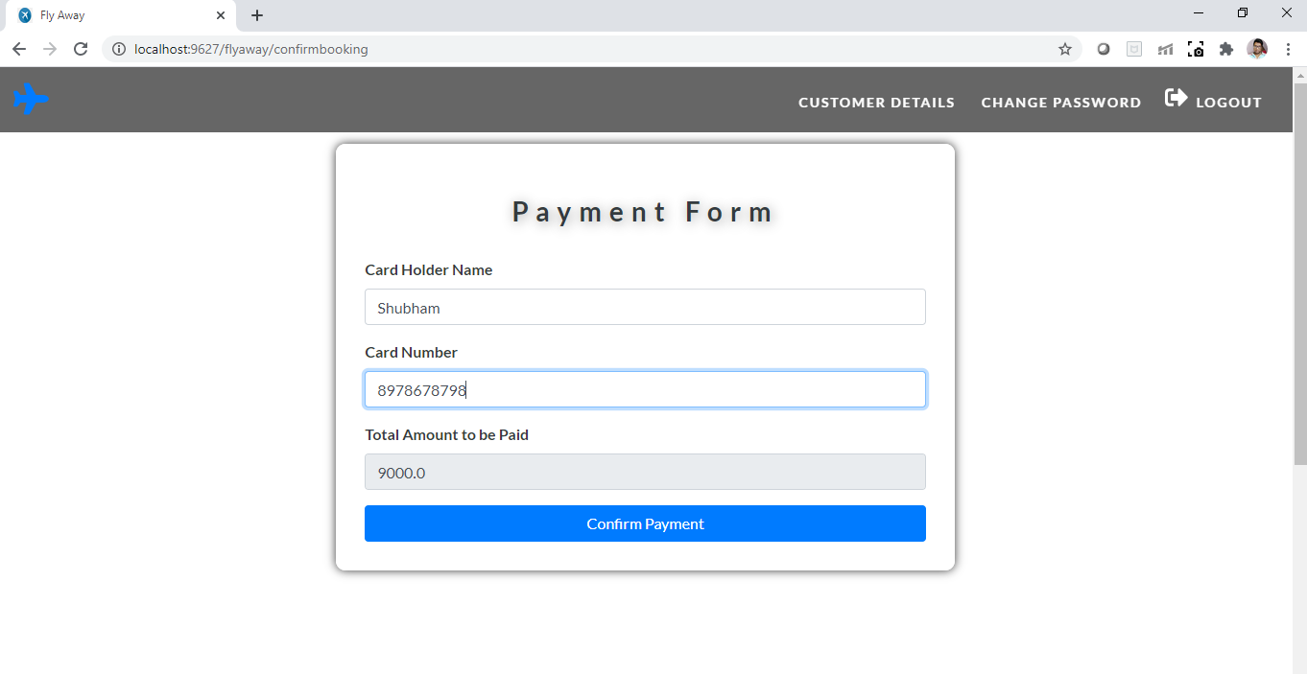

* 1. **After confirming payment user will be forwarded to Ticket details page where they can see all the details of their journey and payment. At this step the journey details are stored in the database. User can also print their tickets with print ticket button.**

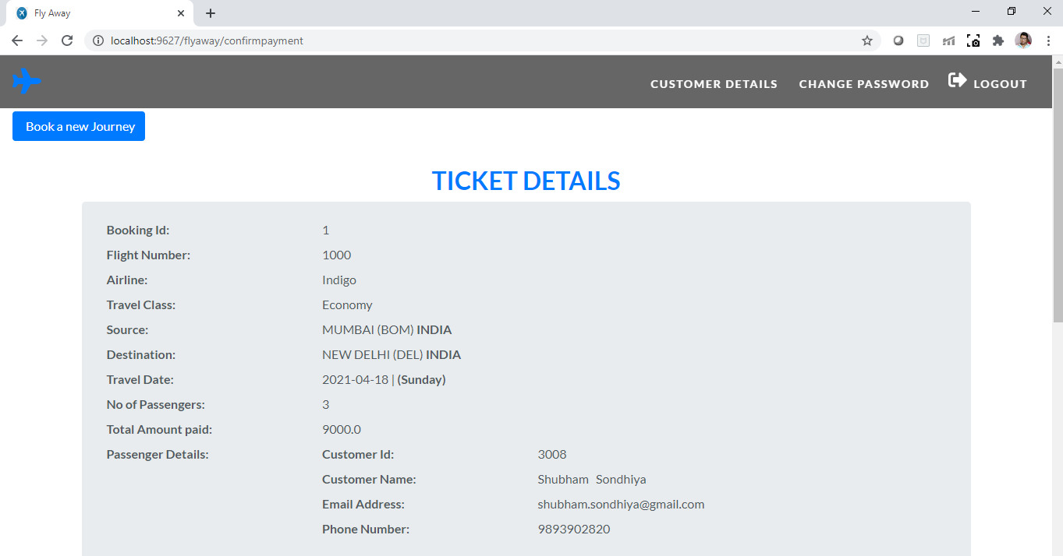

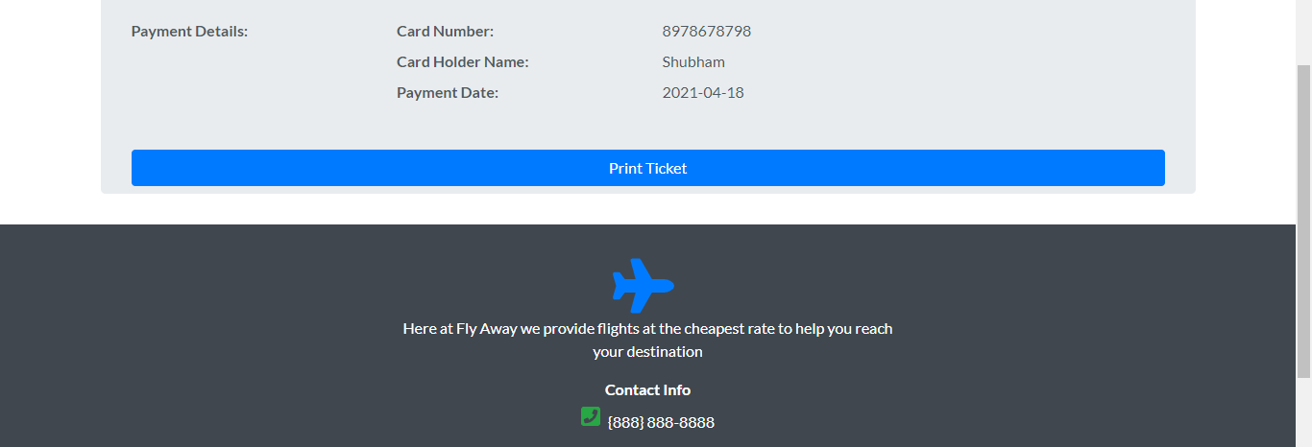

**We can also confirm in the database the booking details are stored here.**

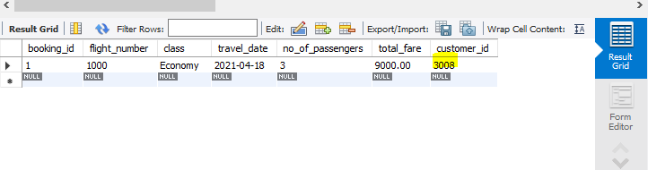

**Booking details are stored for customer id 3008.**

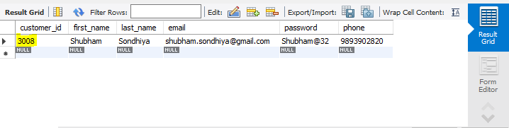

* 1. **If the user choses customer details from the navbar then they will be forwarded to customer details page where they can see all their booking details, Also they have a Book a New journey link with which they can book a new journey.**

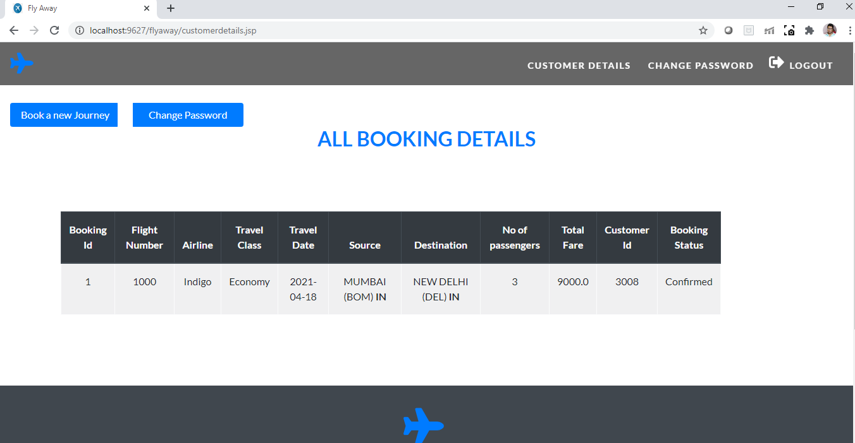

* 1. **If the user is already logged in and want to book a new journey (Notice Navbar changed). (In this case user will not be asked to register again as they are already logged in).**

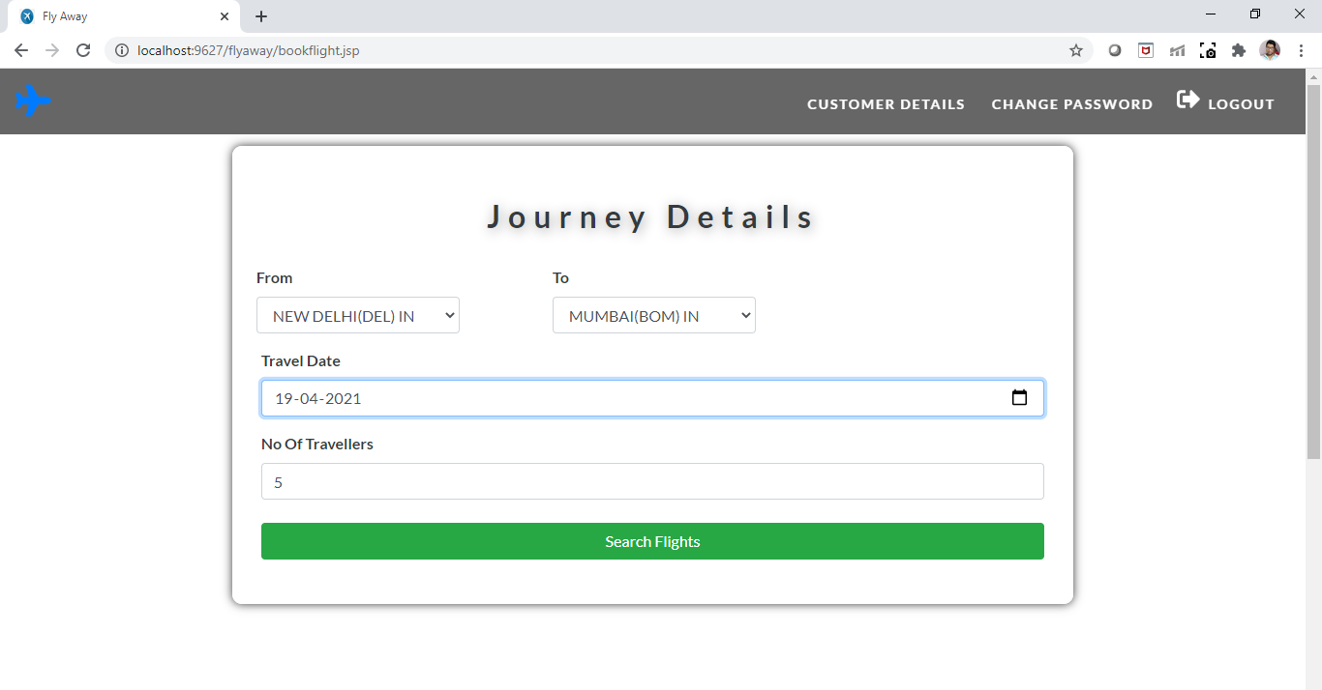

* 1. **If valid details are entered. User will be shown all the Flights available from Mumbai to Delhi on Sunday. User can select any airline from the list and compare their fares by clicking on (Book Tickets).**

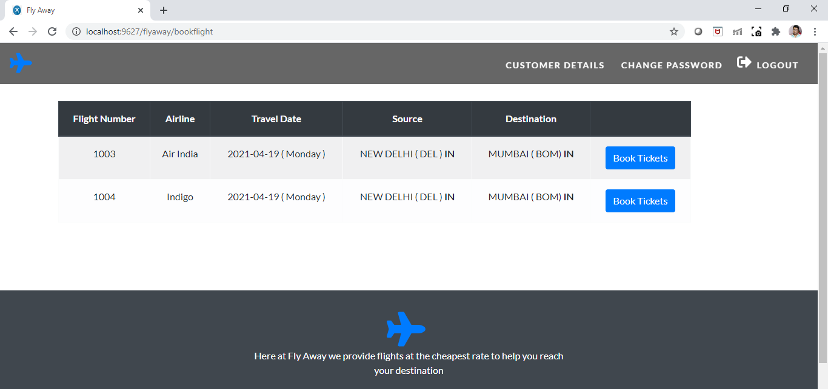

**We confirm from the database only 2 flights are available for Monday from Delhi to Mumbai.**

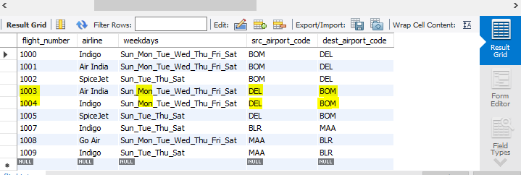

* 1. **If user selects an airline from the list (here 1004). User will be directed to fare details page where all the different classes are shown with fares. (User can book tickets on any class of their choice).**

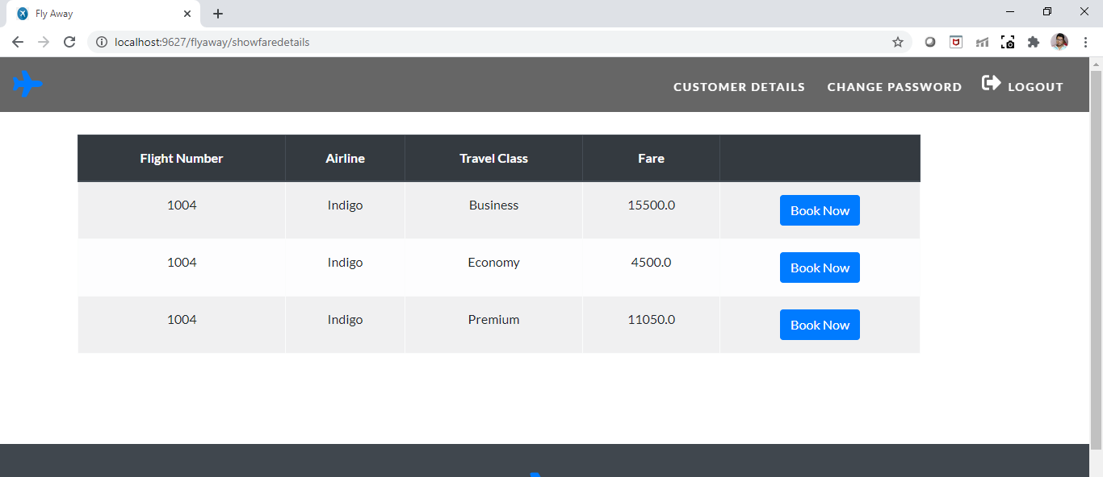

**We can confirm from the database the list of fares for flight 1004.**

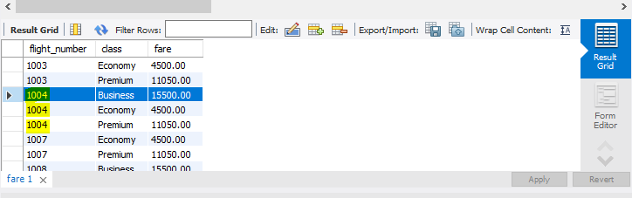

* 1. **If the user is already logged in then they are forwarded directly to Booking details page where they will see all their booking related details after confirming details, they can click on confirm Booking.**

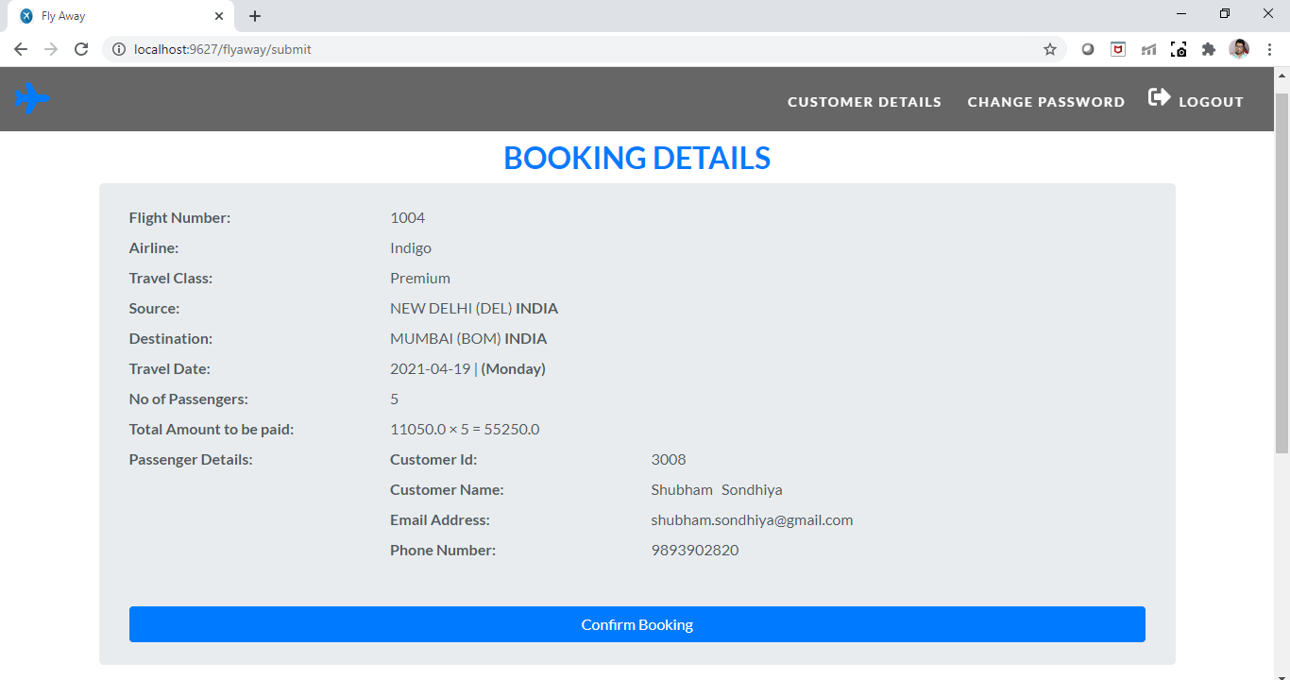

* 1. **After Confirming booking details, user will be forwarded to payment form where they need to enter payment details like Card Name and Card Number. They can also recheck the amount to be paid, And confirm payment.**

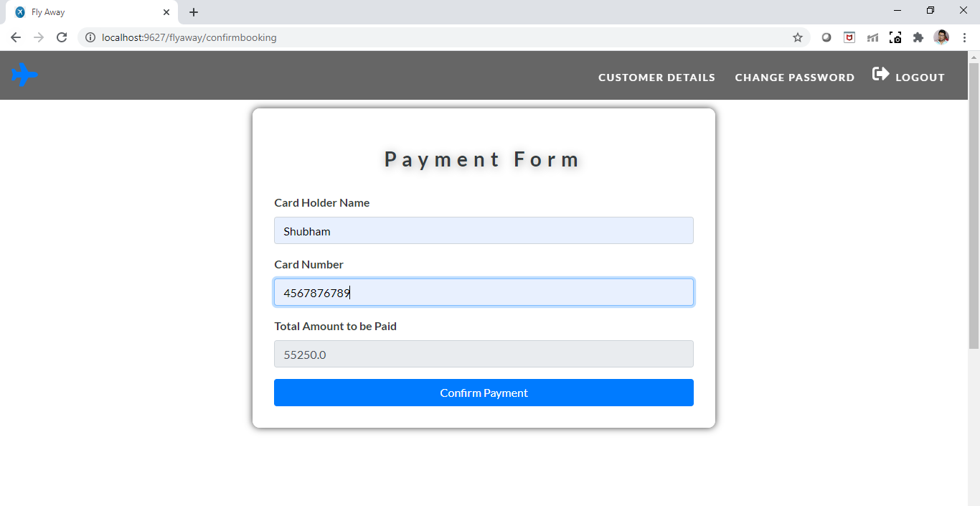

* 1. **After confirming payment user will be forwarded to Ticket details page where they can print their ticket.**

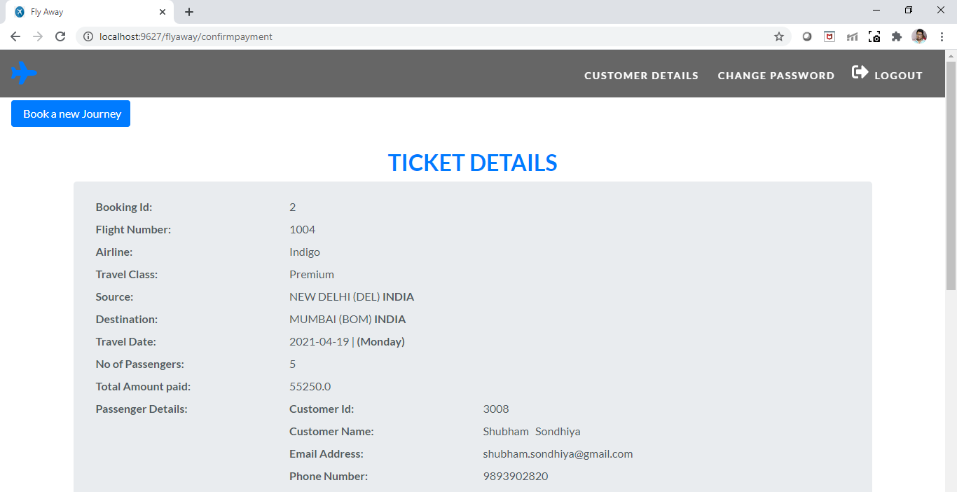

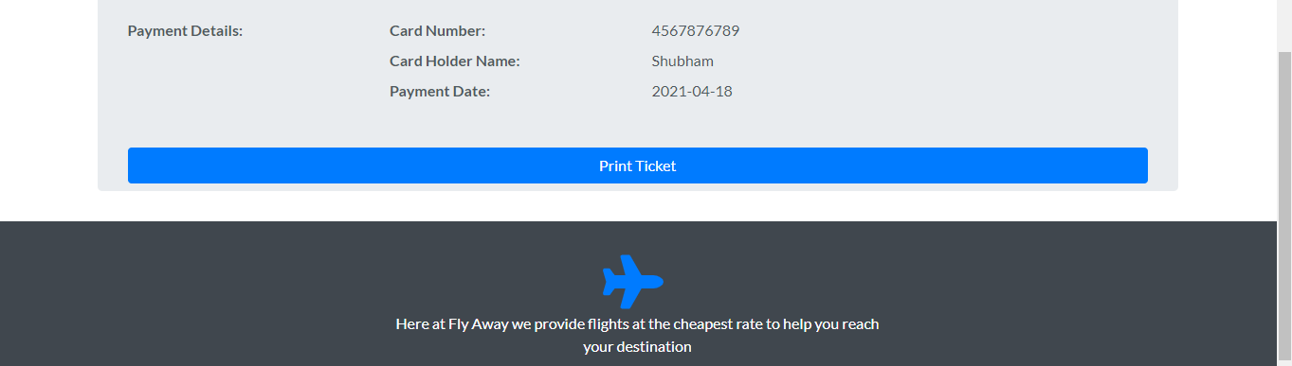

**We can also confirm from the database new booking details are present for the same user 3008.**

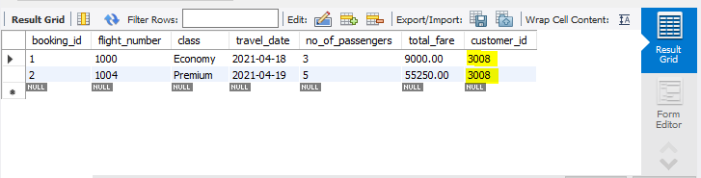

* 1. **If the user choses customer details from the navbar then they will be forwarded to customer details page where they can see all their booking details, Also they have a Book a New journey link with which they can book a new journey.**

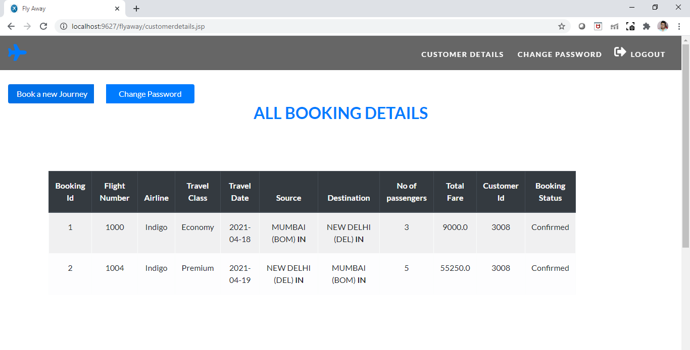

* 1. **User also has the option to change password if they wishes to.**

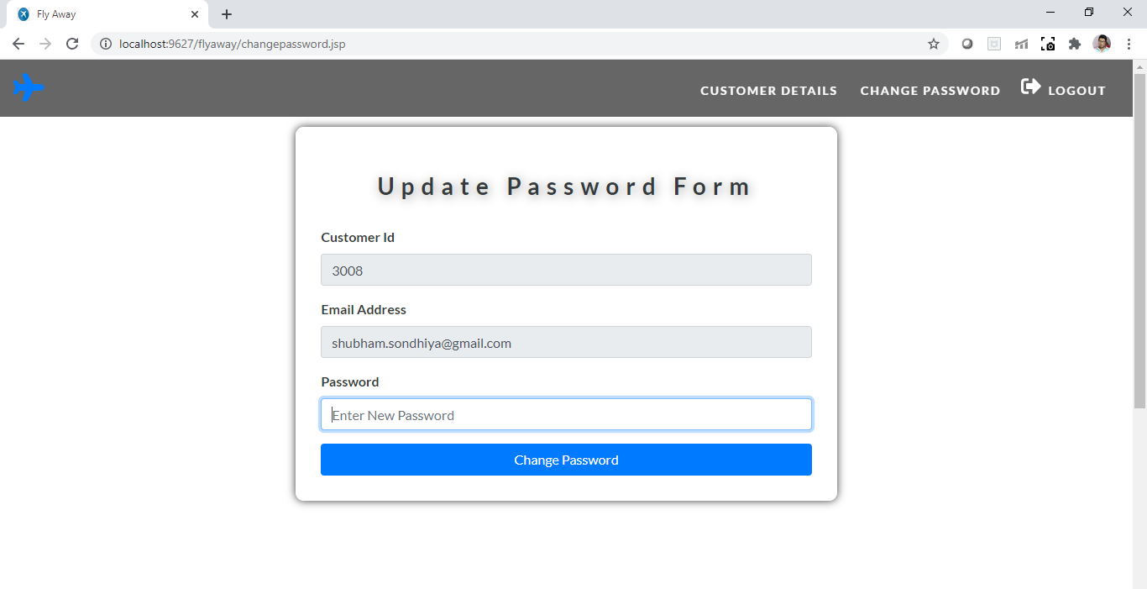

**We can see in the database the old password.**

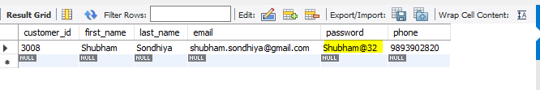

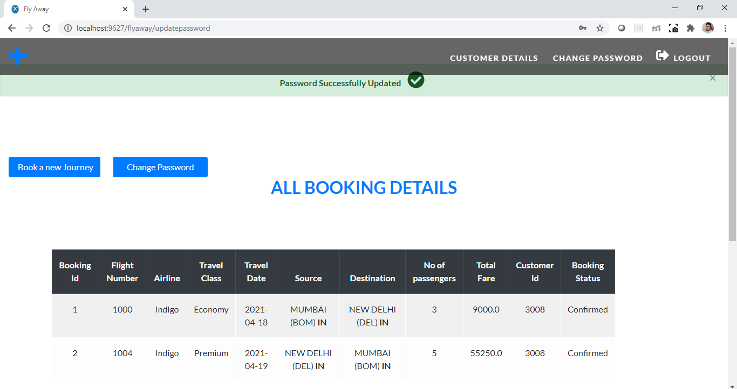

**After password changed successfully the same is reflected in the database.**

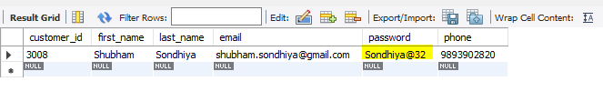

* 1. **If the user selects Logout option, they are redirected to Home page. (Notice navbar changed now).**

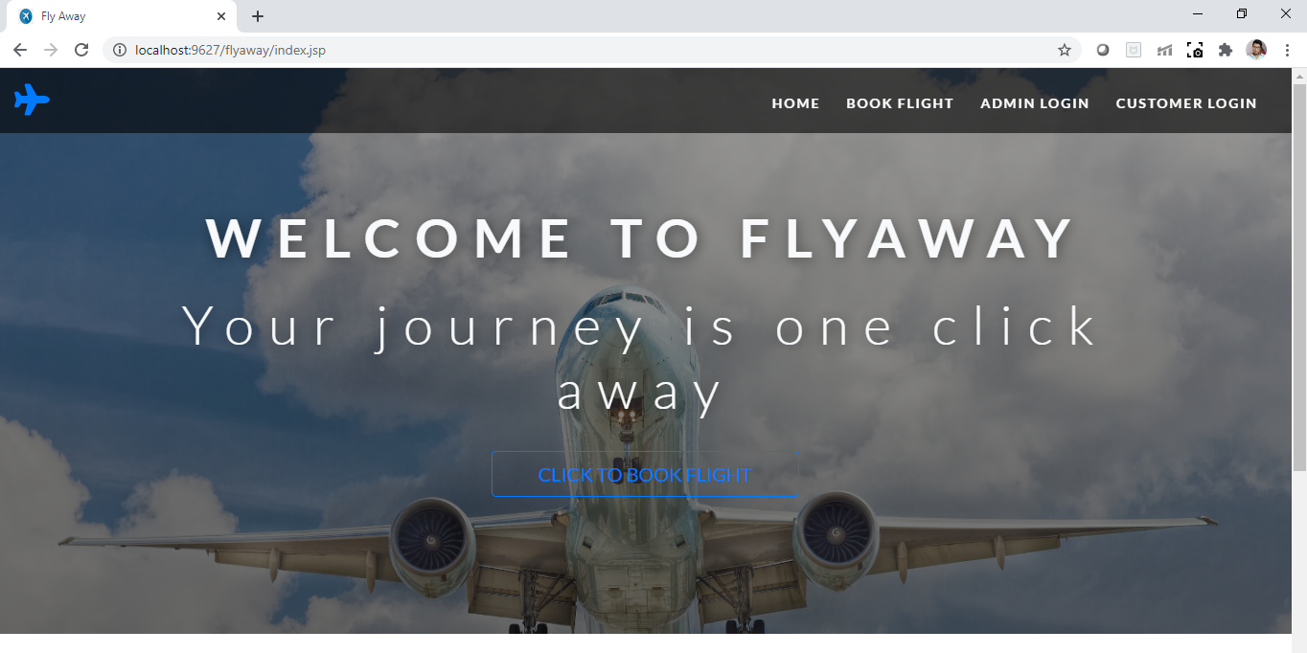

* 1. **If the user selects Customer Login from the navbar then they will be forwarded to Login form where the customer will enter their email address and password.**

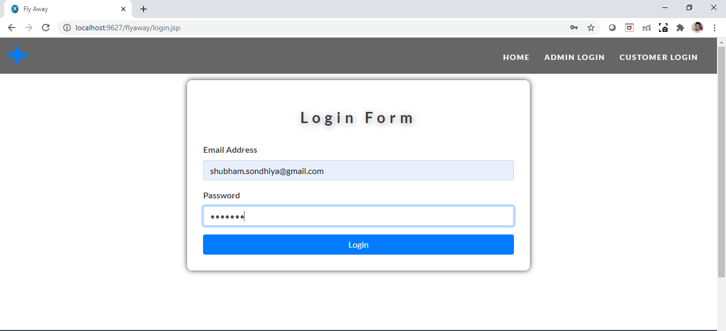

* 1. **If the entered details are incorrect. Incorrect Username or Password error is displayed.**

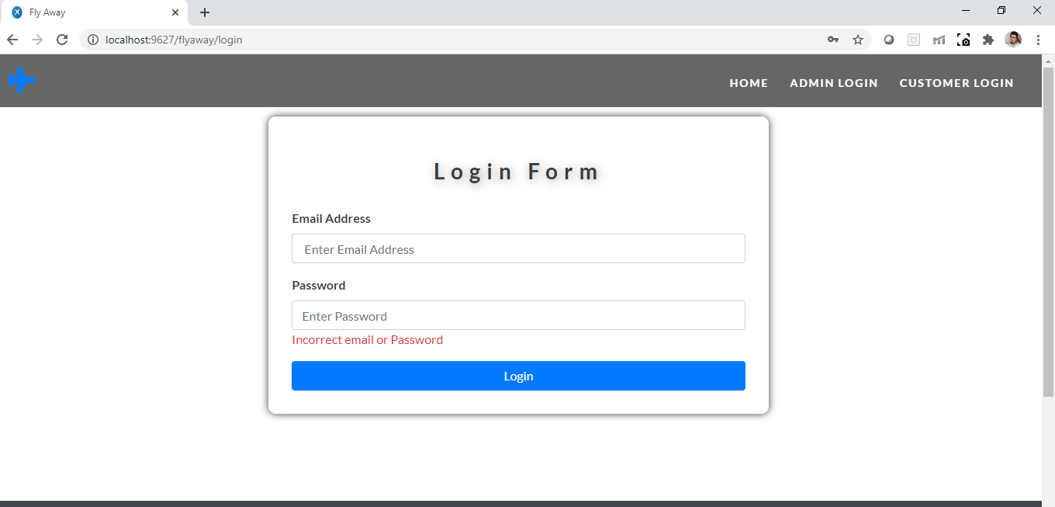

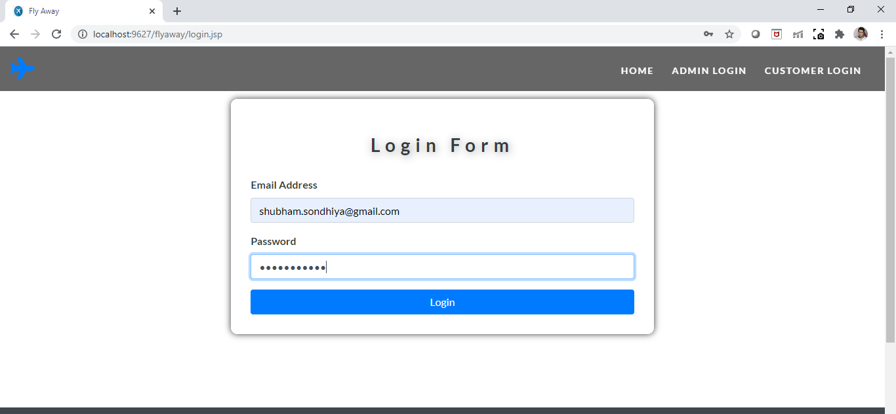

* 1. **If the details entered by user is correct then they will be forwarded to customer details page.**

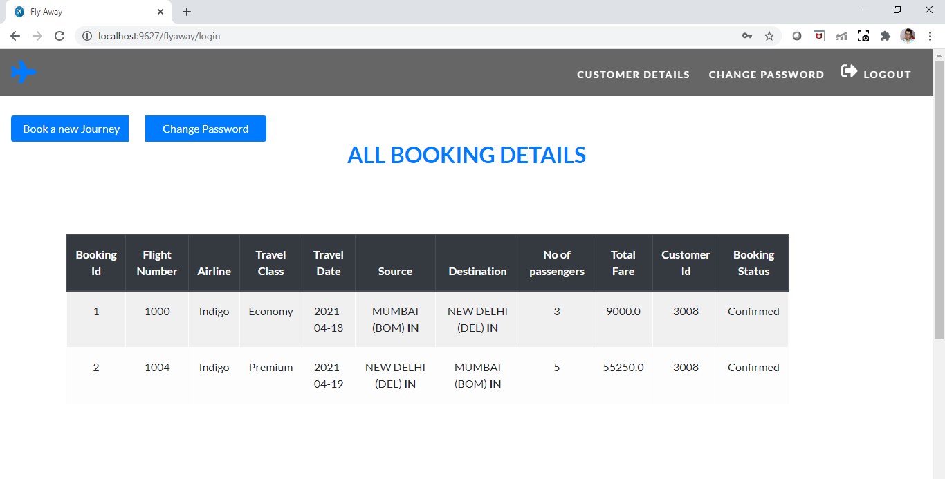

**If the user selects Logout option they are redirected to Home page. (Notice navbar changed now).**

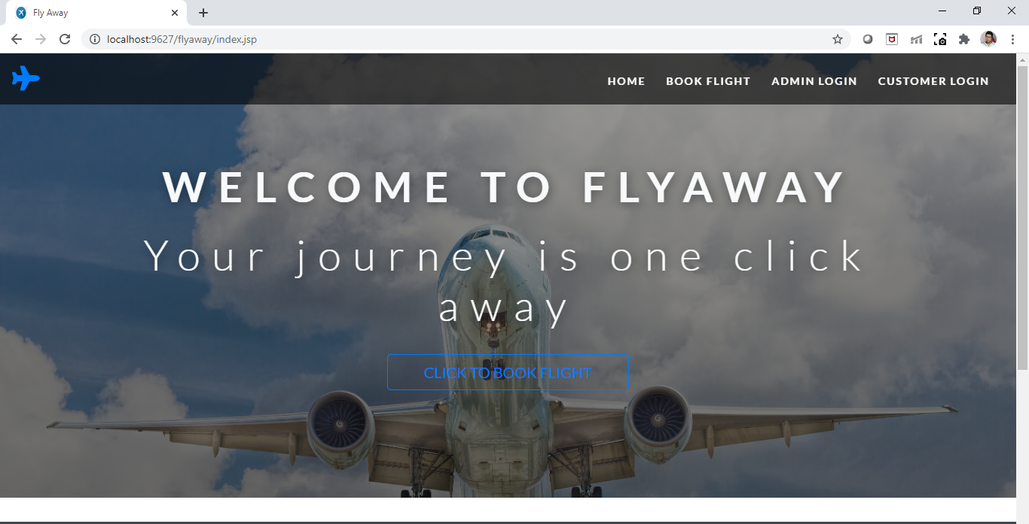

1. **Admin Related Scenarios:**
   1. **Home Page Admin can go in Admin Details by choosing Admin Login in navbar.**

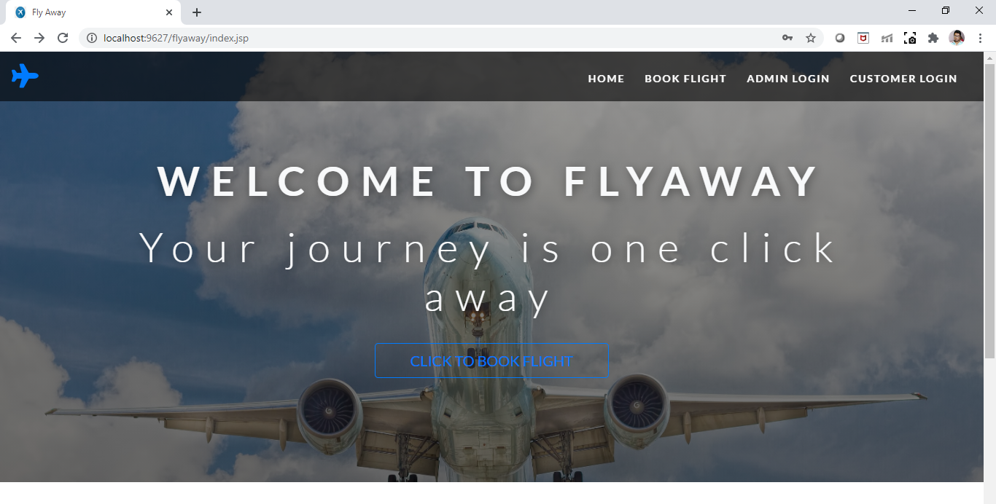

* 1. **Admin can login by providing email and password**

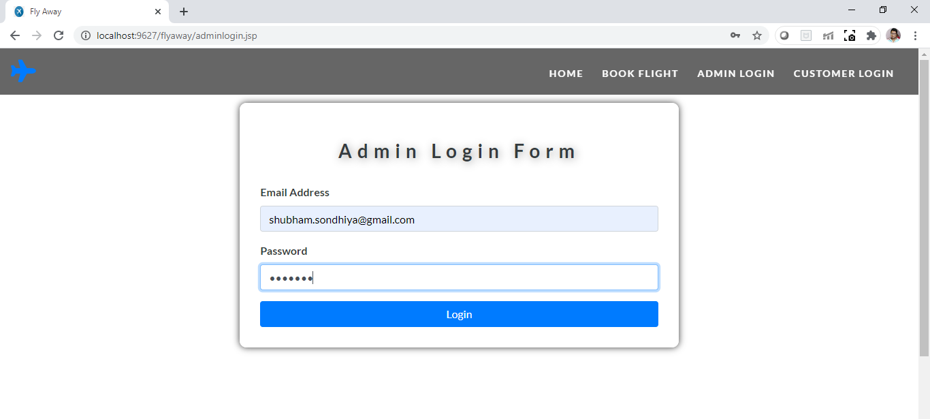

* 1. **When Admin enters incorrect email and password.**

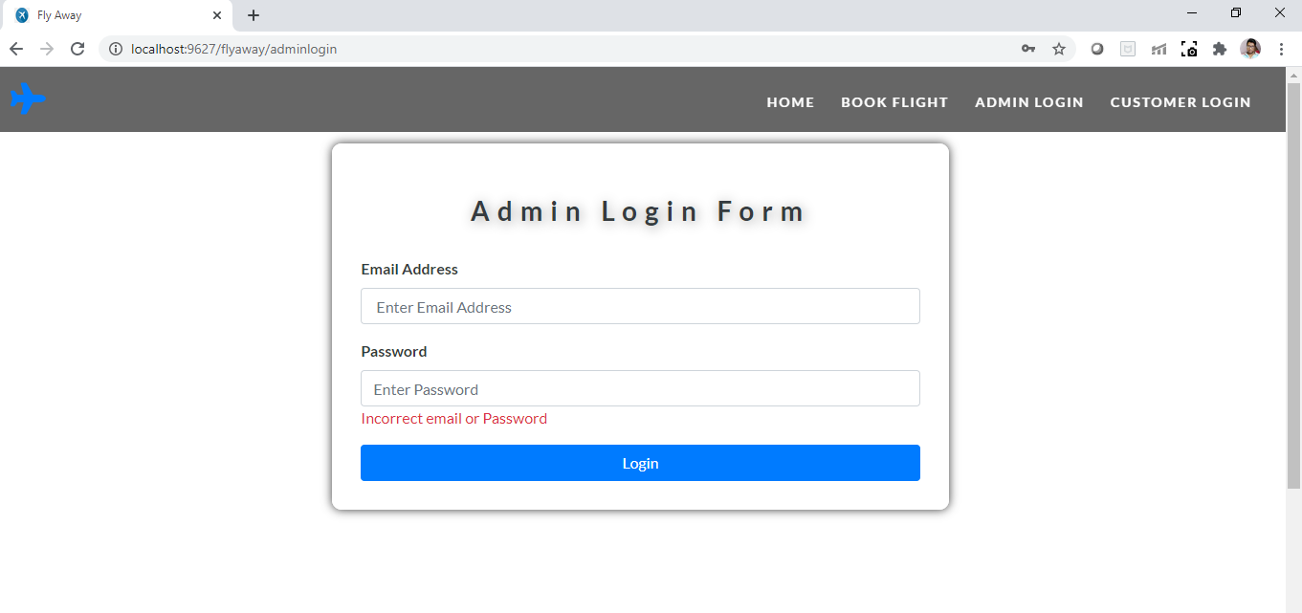

* 1. **When Admin enters correct details then they are forwarded to Admin details page where they can see All the flight details and options to add flight and change password.**

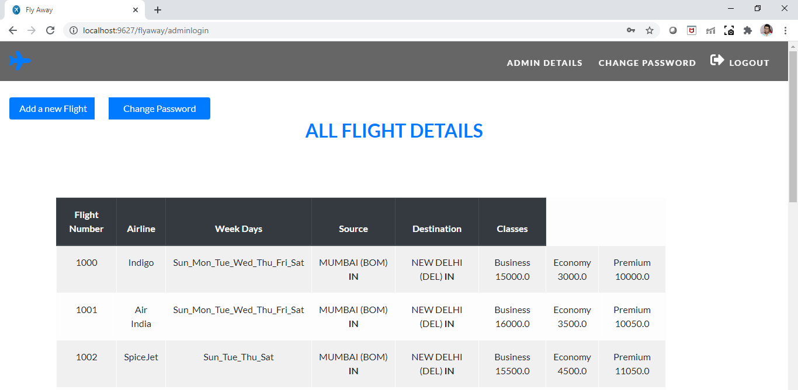

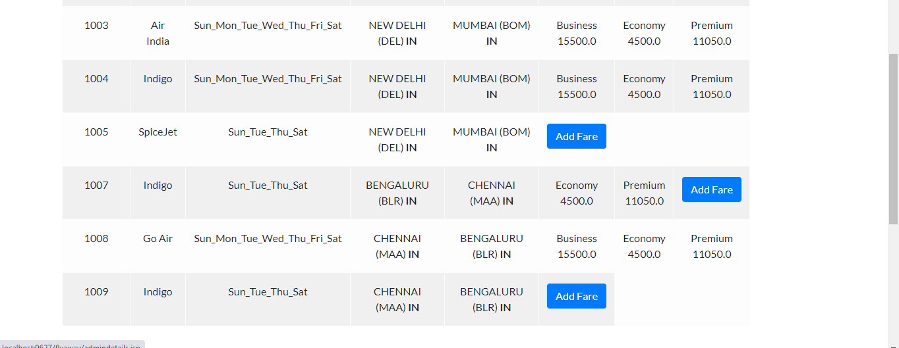

**We can check all the Flights in the database**

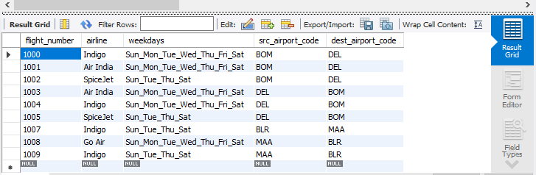

**A check has been placed for Flight classes. As for now each flight can have maximum of 3 classes. If the flight already have 3 classes then (Add Fare) option is disabled in that case. If the Flight as less than 3 classes then there is an option where Admin can add Fare details for different classes.**

* 1. **Admin can add a new flight with Add New Flight option.**

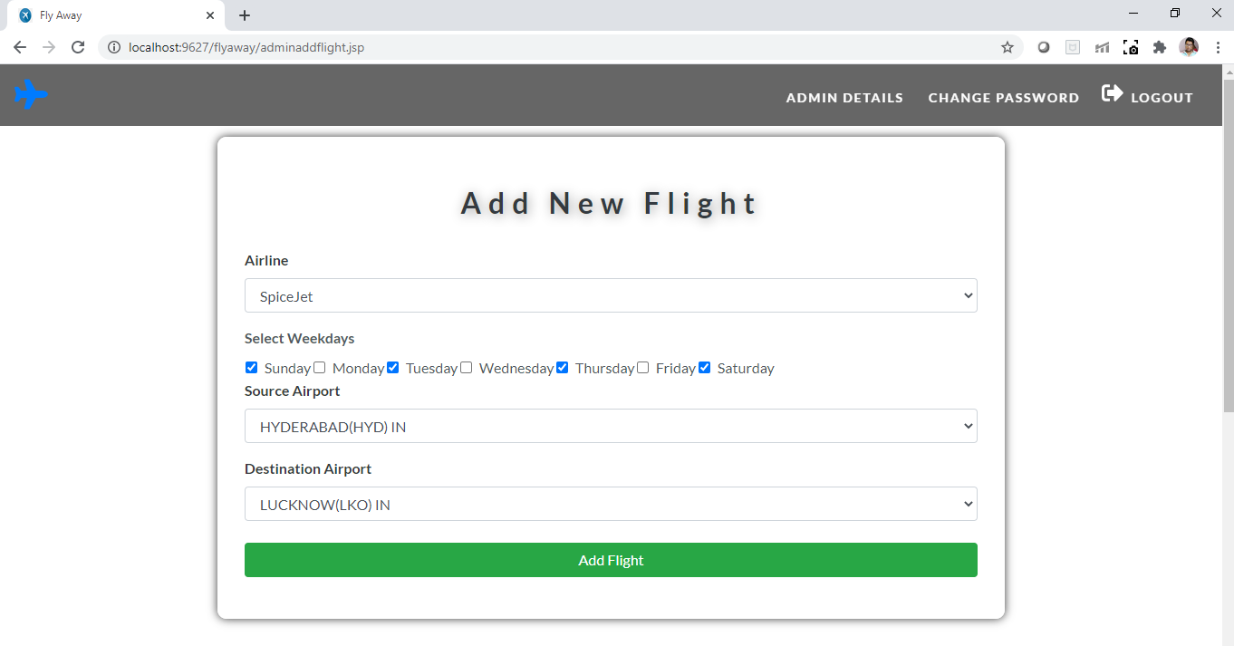

* 1. **If all the details entered by user is valid then flight successfully Added message is displayed.**

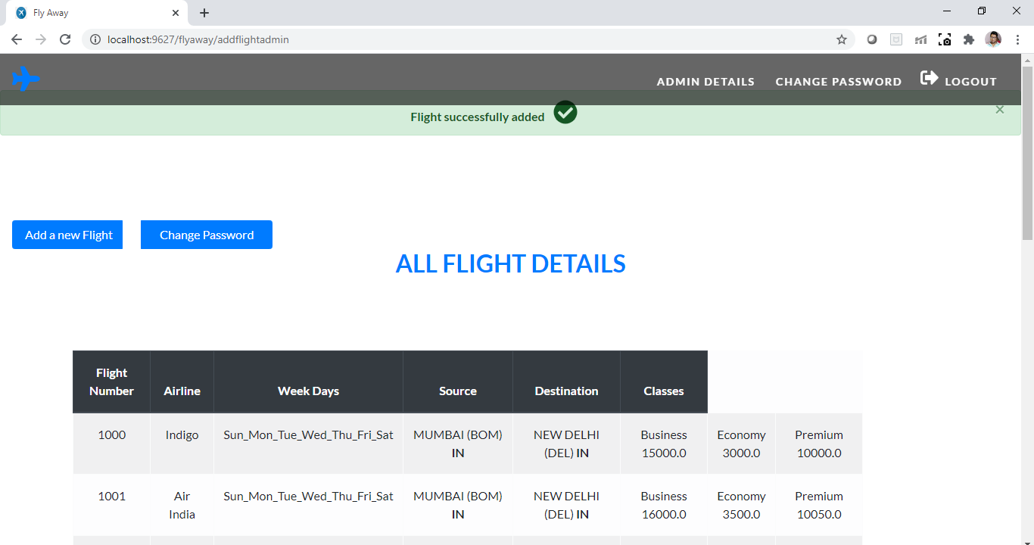

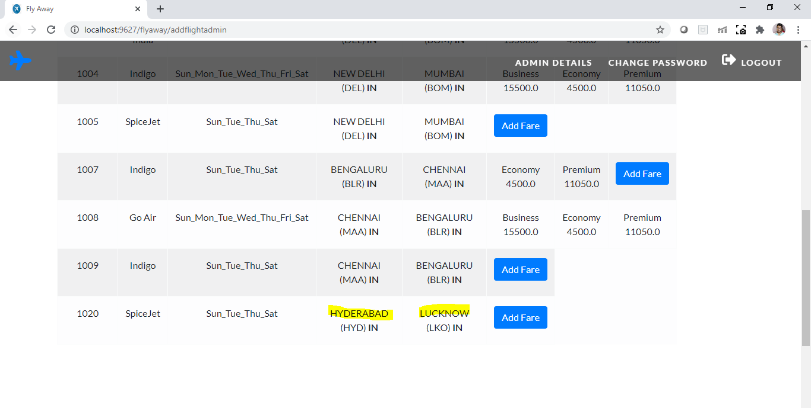

* 1. **Admin can Add Fare details for the newly added flight (1020)**

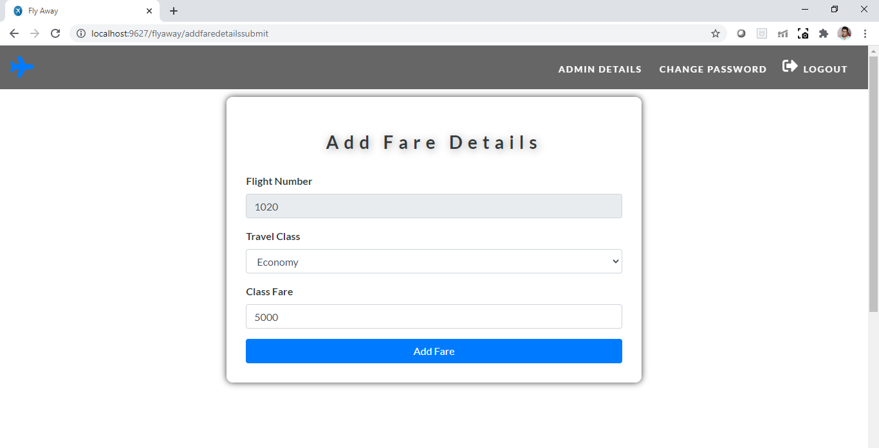

* 1. **If the fare details are valid then fare Details are successfully added**

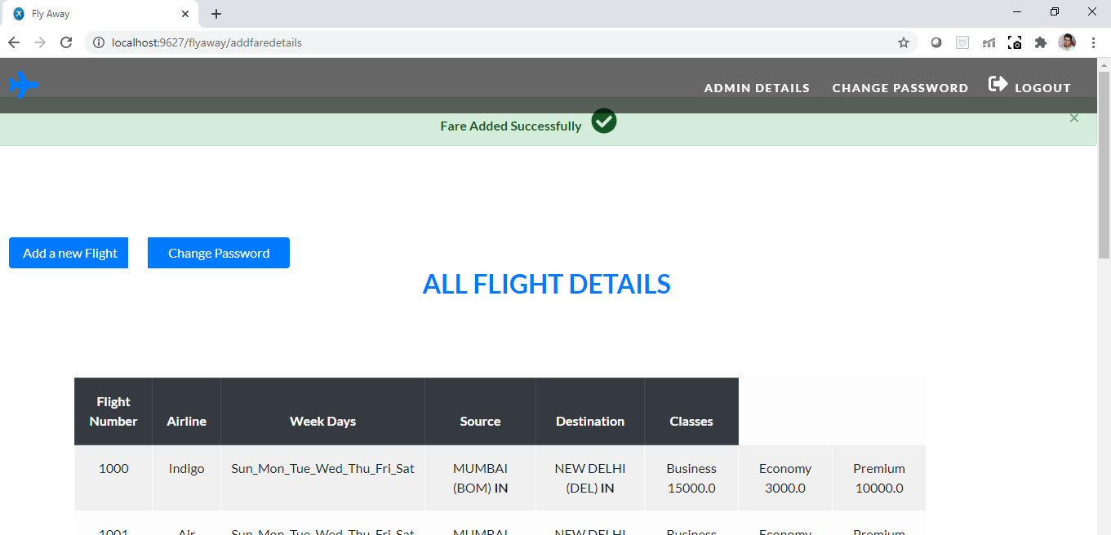

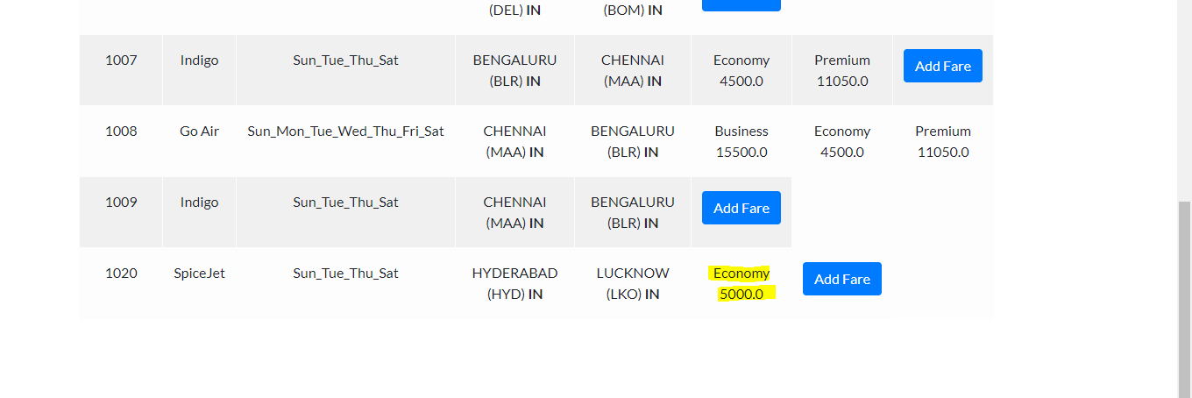

**When all 3 classes fare details are added to the newly added flight then Add Fare Option is disabled.**

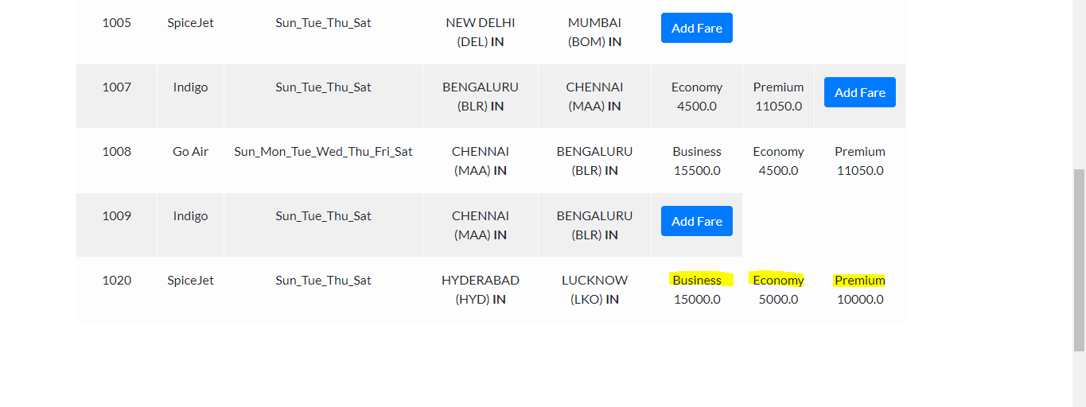

* 1. **Admin can change their password if thet wishes to.**

**Before case Password:**

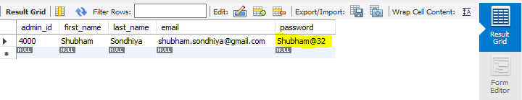

**Update password form:**

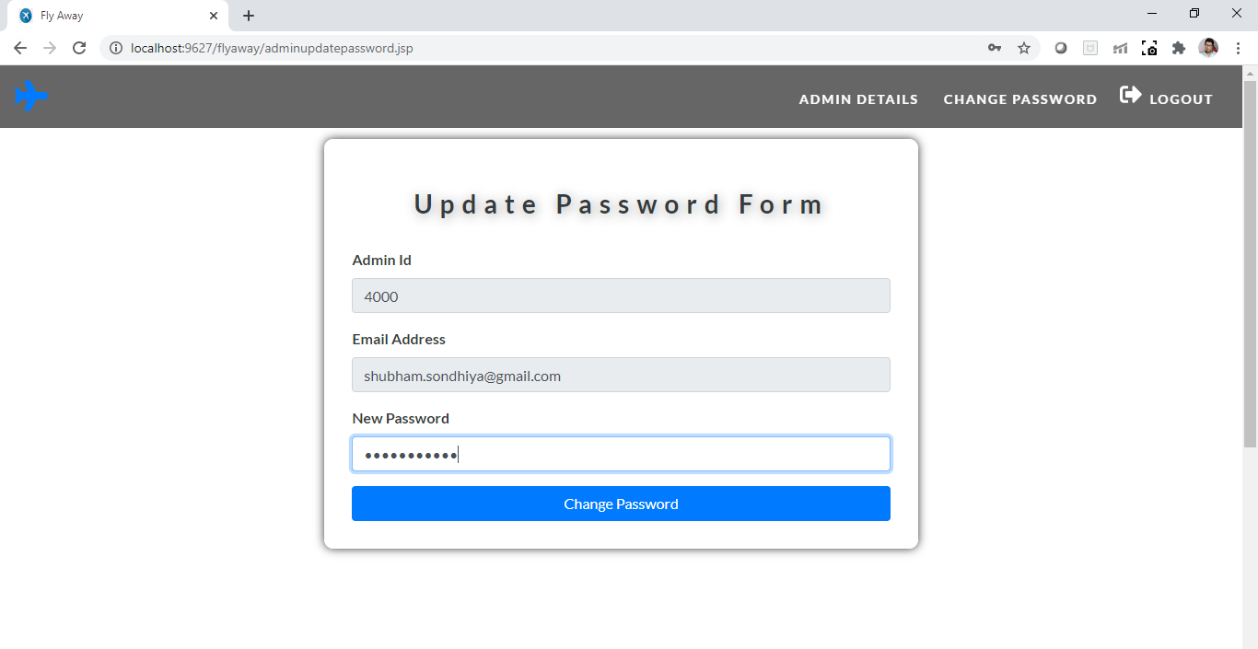

**Password Updated successfully:**

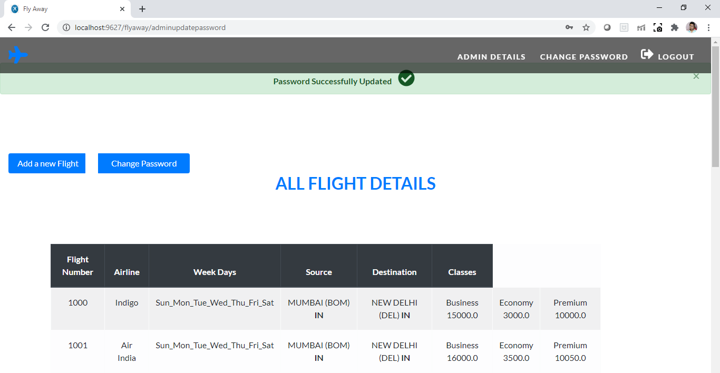

**Checking for password updation in the database.**

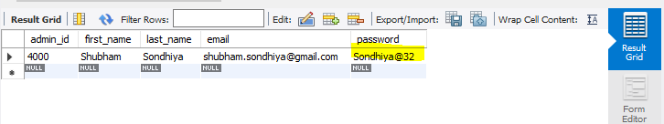

* 1. **Admin can logout from the Application from where they will be forwarded to Home page.**

